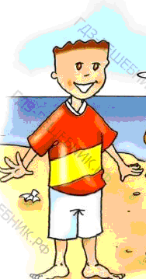
This is me on my summer............. I’m wearing a red ................
аnd а white ...........

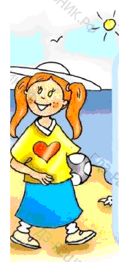
This is me on my.............. holiday.
I’m wearing a.....……..hat,
a yellow .............. and a blue ...............

